**Remote DC Motor Monitoring and Controlling System**

|  |  |  |  |
| --- | --- | --- | --- |
| Subject: Advanced System Software Project | | | |
| Team: noob | | | |
| **Index** | **Name** | **Student ID** | **Roles** |
| 1 | LANG, Chen | 18M38127 | Project Manager;  Peripheral Hardware Designer;  Motor Controller Software Developer |
| 2 | ZHANG, Zhiyang | 18M38185 | Remote Controller Software Developer;  Testing |
| 3 | GAO, Tianyang | 18M38110 | Remote Controller Software Developer;  Testing |

**Summary:**

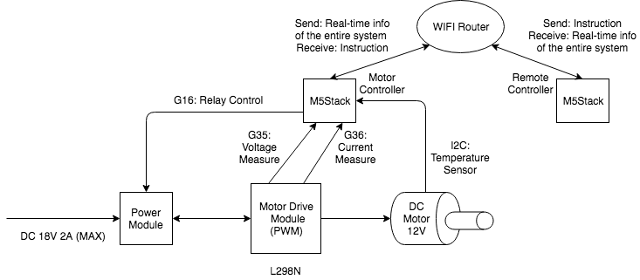

Our project is a DC motor controller with a remote monitoring and controlling functionalities. The DC motor is controlled by the M5Stack device named “Motor Controller”. All the system information, that are voltage, current and temperature, will be collected by “Motor Controller” and sent to the other M5Stack device named “Remote Controller”. The LCD of “Remote Controller” displays all the system information.

Also, “Motor Controller” is responsible for protecting the circuit. If the voltage, current or temperature is abnormal, the controller will cut off the main power supply by controlling the relay via pin G16.

So, there are mainly 3 periodic tasks in “Motor Controller”: communication task, monitoring task, and motor drive task. Since motor drive task needs to generate PWM wave, it has the shortest period and the highest priority. Monitoring task is responsible for protecting the circuit, so it has the second shortest period. Communication task is the least important, so it has the longest period and the lowest priority.

In addition, user can use button to send instructions via the “Remote Controller” to “Motor Controller” and then control the speed and the direction of the DC motor. Besides, these two M5Stack devices communicate via WIFI.